**1.Write a blog on Difference between HTTP1.1 vs HTTP2**

HTTP(Hyper Text Transfer Protocol) is the set of rules for transferring files such as text,picture,video and other multimedia files over the web.HTTP is an application protocol that runs on top of the TCP and IP suite of protocol Which forms the foundation of internet.

HTTP1.1 was published in 1997 and HTTP 2 was introduced in 2015.

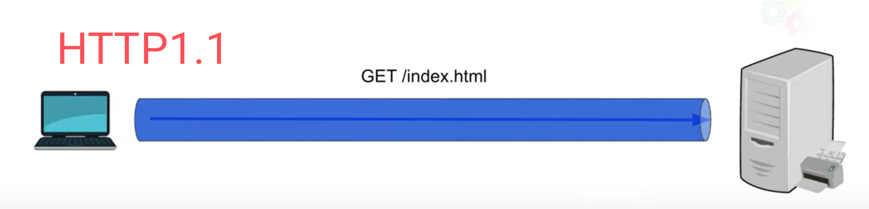

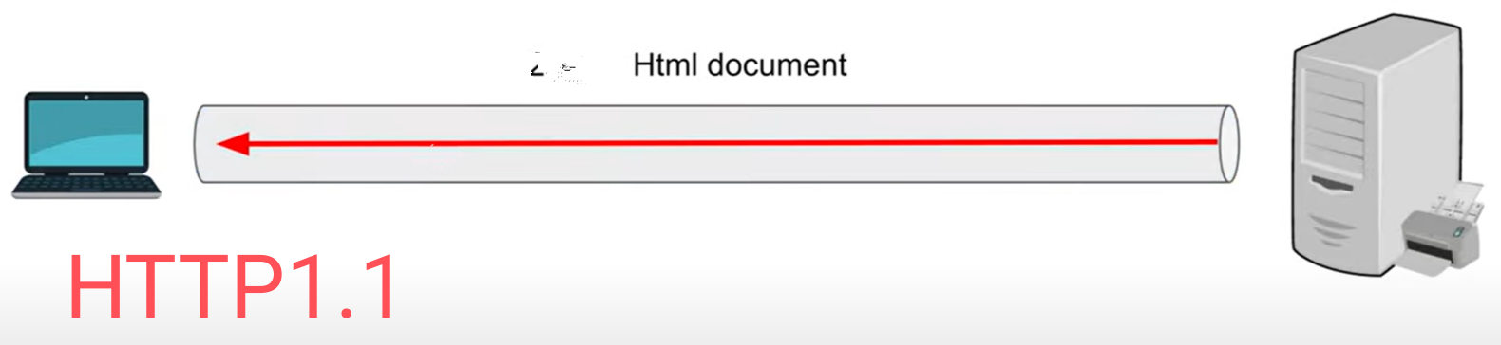

In HTTP1.1 the browser made a TCP connection with the server inorder to get the needed resources to load the webpage from the server.Unlike HTML1.0,HTML1.1 use **KEEP-ALIVE** method to keep the TCP connection between browser and the server.Multiple requests and responds can be processed through that single TCP connection it's called as ***Persistent connection***.For example if a browser send a request to get a HTML file from the server,the server responds to that request and send that HTML file to that browser.The webpage doesn't have only the HTML file it also contain some other supportive files like JS,CSS,PICTURES etc...This is Where the problem arise the browser must wait to send the another request for receiving the required data this is called Head-of-line blocking.

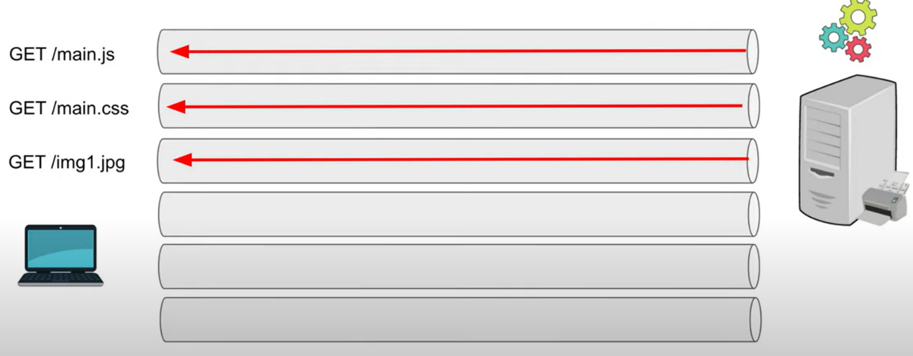

To resolve it browser and server made several other TCP connection inorder to transfer the individual files through individual connection like HTML in one connection and JS,CSS,PICTURE each through seperate connection.But there is a limitation for howmuch connection to be made to over come this HTTP2 comes with multiplexing.After the TCP connection is made Within this connection there are multiple streams of data.Each stream is used to send request and receive respond by this the latency period was reduced.

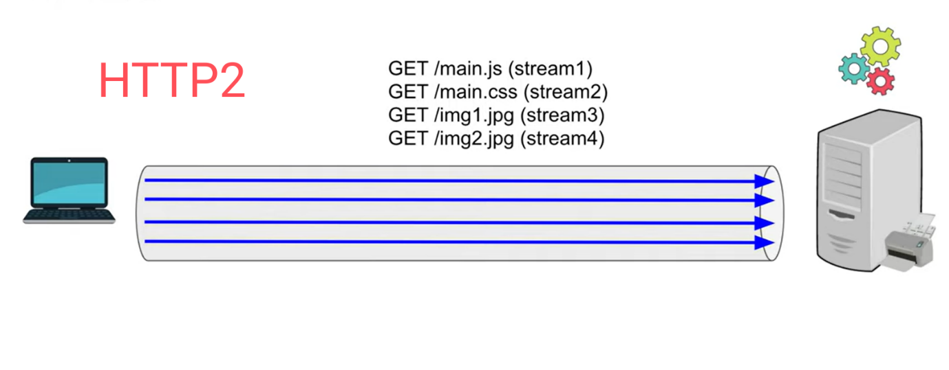

There is also one important thing contained by HTTP2 Which is PUSH.In HTTP1.1 it use **GET** method every time to receive the required data from the server.So that first a request of HTML file was send by the browser after that it use another Get methods to receive the CSS file and the same thing is repeated to receive all the necessary files to render the webpage this process increase the rendering time for the browser.

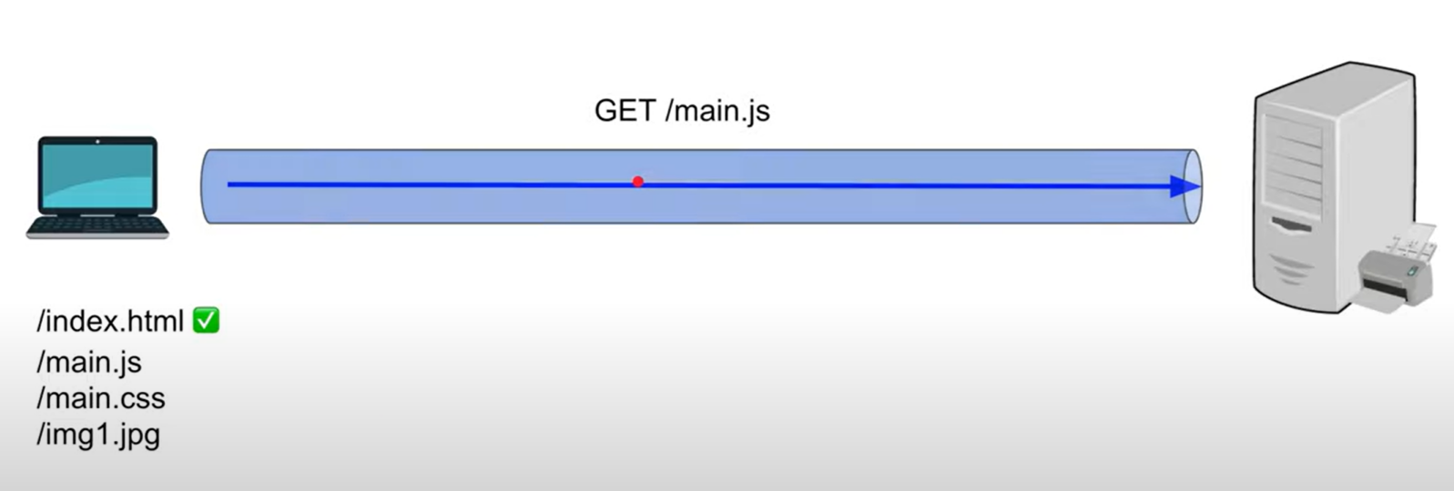

HTTP2 use **PUSH** method to resolve the above problem.When the browser sends a request for HTML file the server understand it and attach all the other necessary files(CSS,JS,PICTURE & OTHERS)which are needed or linked with the requested HTML file.

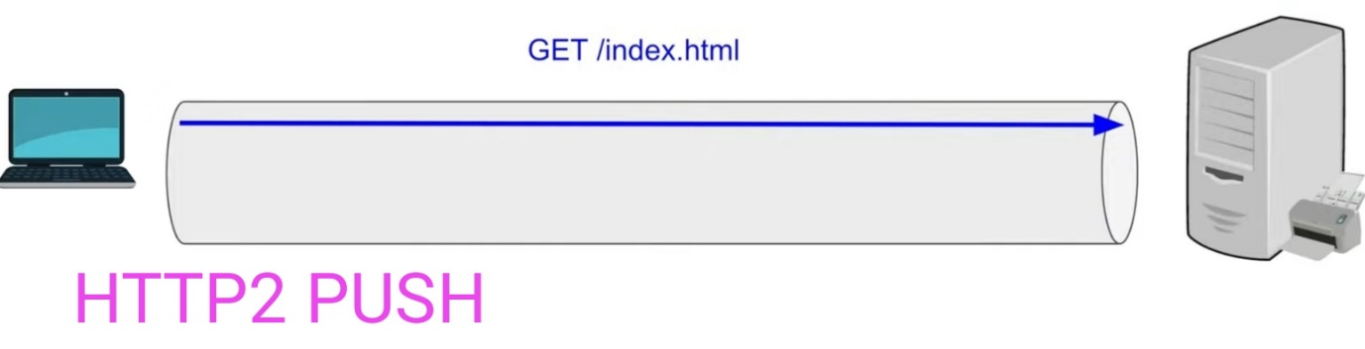

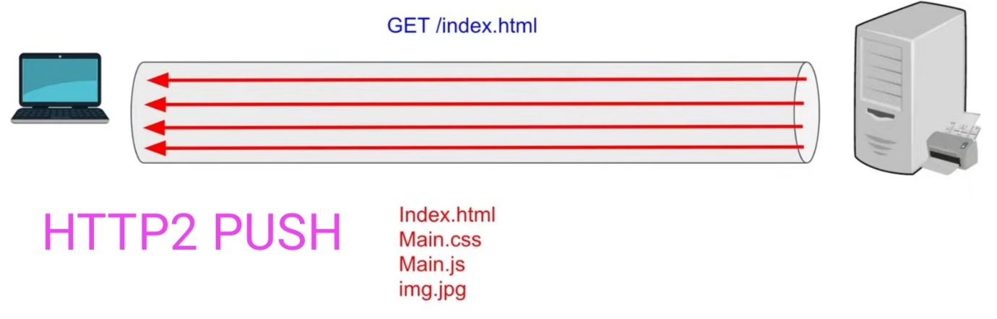

In addition to that HTTP2 use **HPACK** to compress the header file. A common method of optimizing web applications is to use compression algorithms to reduce the size of HTTP messages that travel between the client and the server.

|  |  |
| --- | --- |
| **HTTP 1.1** | **HTTP 2** |
| * It works on textual format. | * It works on binary protocol. |
| * It send multiple request to get all the * files for loading the webpage. | * It use PUSH to collect multiple files at * A time. |
| * It compress data by itself. | * It use HPACK to compress the data. |
| * Head of line blocking blocks all other request until it gets the resource.It create a queue of request. | * Multiplexing make multiple request to gets its resource without blocking. |

**2.WRITE A BLOG ABOUT OBJECT AND ITS INTERNAL REPRESENTATION**

* Object is one of the data type in javascript.
* An object is a reference data type.
* It contain both primitive and reference data type in it.
* An object is a collection of data in the form of KEY:VALUE pair.A single key,value pair is called property.And a property name also called as key name is always a string and
* the value can be anything.
* An object can hold Number,Boolean,String,Array.

*object property*:

* An object can be created with curly braces {...}
* Inside the object every data are arranged in key,value pair.
* Every property is seperated by a comma in the object.
* I can have nested object.

let guvi_students = {

Name : ”xyz”,

Batch : 01,

Course : ”full_stack”,

isStuding : true ,

Qualification : ”BE”,

};

*How to access object*:

1) Dot notation

eg: objectName.key

2) Square bracket notation

eg: objectName["key"]

The property name can be a string or number.Incase the property name is a number then it must be accessed through bracket notation.

*Iterating the key in object*:

for…in can be used to iterate the object.

eg: for(var key in objectname){

console.log(key);

}

*How to insert a property* :

This method is used to insert a new key to the object.

Syntax : objectname.keyName = value ;

*How to update a property :*

This method is used to change the previous value of the key.

Syntax : objectName.keyName = ”……” ;

*How to delete a property :*

This method is used to delete a property from the object.

Syntax: delete objectname.keyName ;